Slide 1
Slide 2
Slide 3
Slide 4 | 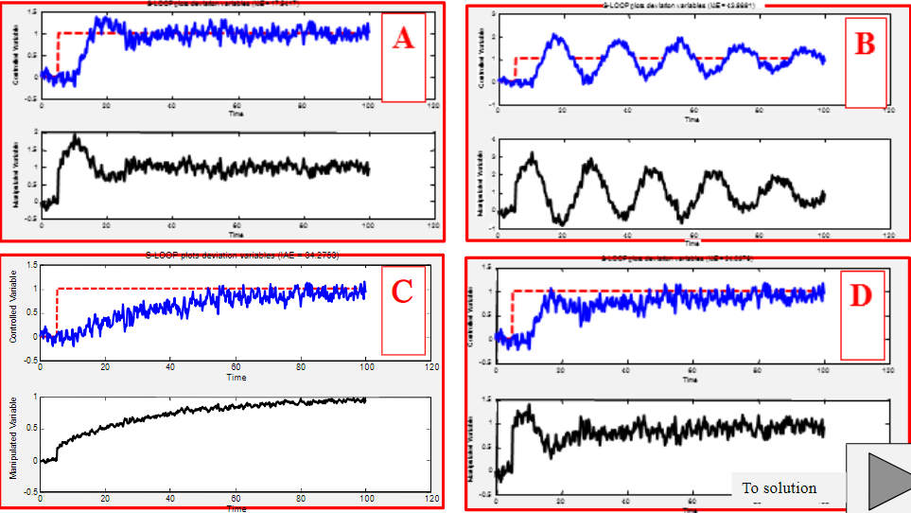
Slide 5
Slide 6

